Board of Advisors

Abbey, George W.S.
Albaugh, James F.
Aldridge, Edward C.
Bolden, Charles F.
Brandenstein, Dan
Cabana, Robert D.
Callahan, Lisa
Campbell, Donald J.
Carr, Jeffrey E.
Carreau, Mark E.
Cazes, David
Chilton, Kevin P.
Coats, Michael L.
Collins, Eileen M.
Cothran, Brad
Covey, Richard O.
Crippen, Robert
Culbertson, Frank L.
Dittemore, Ronald D.
Elachi, Charles
Elbon, John W.
Engle, Joe H.
Flynt, G. Allen
Free, James M.
Fuqua, Donald
Gerstenmaier, William H.
Griffin, Gerald D.
Griffin, Michael D.
Grunsfeld, John M.
Hartz, Jim
Heflin, J. Milt
Hendershot, Cynthia
Hernandez, Jorge
Hieb, Richard J.
Holloway, Tommy W.
Hutchinson, Neil B.
Hutchison, Kay Bailey
Johnson, Sandra G.
Karas, John C.
Kavandi, Janet L.
Kerwin, Joseph P.
Kranz, Eugene F.
Kropp, Debbie
Lightfoot, Robert
Lillard, Randolph
Magnus, Sandra H.
May, Todd A.
McBride, David D.
McDonald, Vernon
Meyerson, Robert E.
Mitchell, Bob
Mulholland, John P.
Nield, George C.
O'Brien, Miles
Ochoa, Ellen
Parsons, William W.
Pickens, Thomas B.
Readdy, William F.
Reightler, Kenneth S.
Schmitt, Harrison H.
Scolese, Christopher J.
Shaw, Brewster H.
Sirangelo, Mark N.
Stafford, Thomas P.
Staples, William A.
Stegemoeller, Charles M.
Stephens, Richard D.
Suffredini, Michael
Swallow, Edward M.
Thompson, David W.
Truly, Richard H.
Vantine, William
Wagner, Elizabeth
Whitesides, George
Wyche, Vanessa E.
For Immediate Release January 26, 2023
Media Contact: Lindsey Cousins
281-723-5683, lindsey@baysidegraphics.net

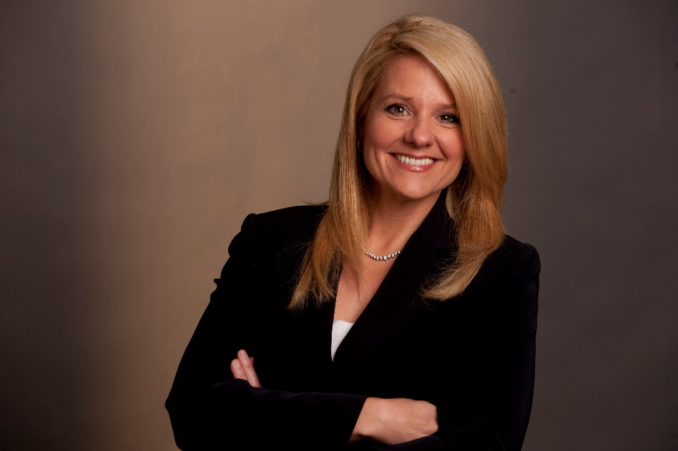

Gwynne Shotwell, President and COO of SpaceX, to receive the 2023
National Space Trophy

Bay Area, Houston, Texas (January 26, 2023). The Rotary National Award for Space Achievement (RNASA) Foundation has selected Gwynne Shotwell, President and COO of SpaceX, to receive the 2023 National Space Trophy. The banquet honoring Ms. Shotwell will be held on April 28, 2023, at the Houston Hyatt Regency in Houston, Texas.

Rodolfo Gonzalez, president of the RNASA Foundation, said, "The RNASA Foundation is excited to recognize Ms. Shotwell as the guest of honor at the 2023 Space Award Gala.”

Shotwell was nominated for the award by Rob Meyerson, founder and CEO of Delalune Space. In recommending Shotwell, Meyerson described her as “a strong leader, engineer, and trusted partner to NASA, the Air Force, the National Security community, and commercial customers.” In a 2020 Bloomberg article, Matthew Desch, CEO of Iridium Communications Inc. said, “She’s got the technical savvy, and that underpins her being a great salesperson. But she never tries to oversell, and she’s always open and honest.”

Shotwell joined SpaceX in 2002 as its first Vice President of Business Development. One of the company’s first dozen employees, she was initially responsible for selling launches to commercial and government customers before the company had operational rockets.

Shotwell became President and Chief Operating Officer of SpaceX in 2008. She is responsible for day-to-day operations, including production, launch, sales, mission management, finance, and management of all customer and strategic relations to support company growth. As President, she leads more than 10,000 employees.

SpaceX has gained worldwide attention for a series of historic milestones. In 2008, Its Falcon 1 rocket was the first privately developed liquid fuel rocket to successfully reach Earth orbit. In 2012, SpaceX’s Dragon spacecraft became the first commercial spacecraft to deliver cargo to and from the International Space Station, and it continues to be the only private company capable of returning a spacecraft from low-Earth orbit. In 2018, Falcon Heavy made its first launch to orbit – with more than 5 million pounds of thrust at liftoff, Falcon Heavy is one of the most capable rockets flying. SpaceX’s fleet of reusable Falcon launch vehicles are the first and only orbital class rockets capable of re-flight, completing more than 200 missions to-date. In 2020, SpaceX helped NASA return human spaceflight to the United States, and in 2021 NASA selected SpaceX to develop the Starship human landing system to help return astronauts to the surface of the Moon. SpaceX is also deploying its global Starlink network which is licensed to operate on all seven continents and is providing service to more than 1 million customers around the world.

Shotwell grew up north of Chicago and graduated with honors from Northwestern University with a Bachelor of Science degree in Mechanical Engineering and a Master of Science degree in Applied Mathematics. She began her aerospace career at The Aerospace Corporation in 1988, where she spent more than ten years in space systems engineering, technology, and project management. She was promoted to chief engineer of an MLV-class satellite program, managed a landmark study for the Federal Aviation Administration (FAA) on commercial space transportation, and completed an extensive analysis of space policy for NASA’s future investment in space transportation. She was recruited to Microcosm’s Space Systems Division, where she served on the executive committee and directed corporate business development.

Shotwell served on the California Space Authority Board of Directors and its executive committee from 2004 to 2011. In 2014 she was appointed to the Export-Import Bank of the United States Advisory Committee and the FAA Management Advisory Council. Shotwell joined the Polaris Industries board of directors in 2019. She has received the World Technology Award for Individual Achievement in Space, was inducted into the Women in Technology International Hall of Fame, and is an elected fellow of the American Institute of Aeronautics and Astronautics. Through leadership in both corporate and external programs, Ms. Shotwell has helped raise over $1.4 million for STEM education programs reaching thousands of students nationwide. She has authored dozens of papers on a variety of space-related subjects.

The RNASA Foundation invites members of the public and the aerospace community to attend
the black-tie event on April 28, 2023, at the Houston Hyatt Regency, where Ms. Shotwell will be
recognized with the National Space Trophy during the 35th annual RNASA gala. Please visit http://www.rnasa.org/tables.html to reserve your table for the gala and find information about sponsorships and tickets. To reserve a room at the Houston Hyatt Regency, please visit http://www.rnasa.org/houston.html or call 713-654-1234 and request the RNASA group rate.

About RNASA: The Rotary National Award for Space Achievement (RNASA) Foundation was founded by the Space Center Rotary Club of Houston, Texas, in 1985 to organize and coordinate an annual event to recognize outstanding achievements in space and create greater public awareness of the benefits of space exploration. The nonprofit Foundation presents the National Space Trophy and Stellar Awards each year. The RNASA website is http://www.rnasa.org/.

